Name: _____________________________________
Period: ______________________
Starfish Dissection
External Anatomy Proficiency

- Pass off with Mrs. Smith the following body parts – BEFORE CUTTING YOUR STARFISH
  - Aboral surface _____________________
  - Oral surface _________________
  - Mouth ___________________
  - Central body ___________________
  - Arms (or rays) ______________________
  - Eyespots _______________________ (can’t really see but where should they be?)
  - Spine ___________________________
  - Anus _________________________
  - Madreporite _________________________
  - Tube foot ___________________________
  - Ambulacral groove __________________________
  - Eyespot ________________________________
Label the parts on this starfish
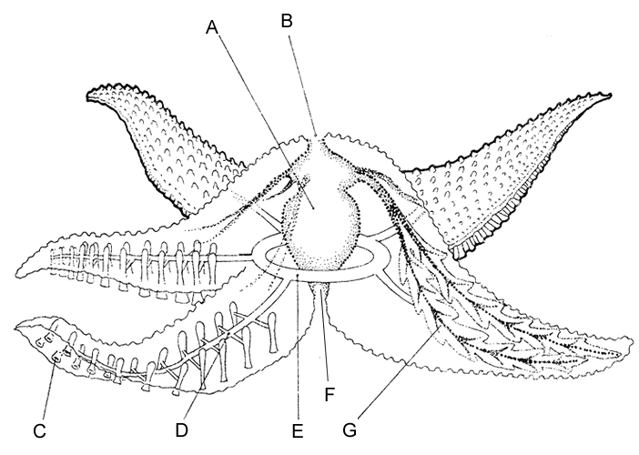

- Check out the skin on the aboral side!!!
  - First feel the skin with your hand – describe the texture.

  - Use the dissecting scope to look at the spines.
  - Some spines look different from others.
    - Some bumps are used to absorb oxygen (dermal branchiae)
      - What survival technique is this?

    - Some bumps are pincher like (pedicellaria) – these are used to clean their skin and some studies show they are used to capture prey!
      - What survival technique is this?

- How many arms (rays) does your starfish have?
  - What type of symmetry do they have?

- Locate the madreporite.
  - What is the purpose of the madreporite?

  - What body system is this part of?
- Look at the tip of the arm (ray)- you need the dissecting scope.
  - Locate the eyespot.
  - What do eyespots detect?

  - What survival technique do eyespots help accomplish?

- Now put the starfish on the oral side.
  - Locate the mouth, with the oral spines surrounding it.
  - What do you think these spines could be used for?

- Now go back to the aboral side – you are now ready to start the dissection.
  - Cut off the tip of a body part (ray).
  - Now cut a window in the top part of the ray.

- Inside each ray, locate two long digestive glands called pyloric cecum. These make enzymes to digest food in the stomach.
  - What survival technique do these organs help accomplish?

- Cut a circular flap of skin from the central disk. (You will also have to cut around the madreporite in order to remove this flap)
- Observe the stomach under the central disk.
  - The stomach aides in which survival technique?

- Remove the pyloric cecum from the dissected ray. Find the gonads (testes or ovaries) underneath. These may be small if the starfish is NOT in breeding season.
  - Why do you think they would be smaller when it isn’t breeding season?

  - What survival technique do gonads help accomplish?

- Now look at the edge of the ray – and cut off the tip. Find the tube feet.
  - Locate the bulb-like top of a tube foot.
  - What is this structure called?

- The canal that connects 2 ampullae together is called the lateral canal. It connects to the larger canal that goes the length of the ray.
  - What is the name of this canal?

  - This canal that extends the length of the ray connects to a circular canal in the central body.
    - What is this circular canal called?
  - This circular canal is connected to the outside by the stone canal.
    - What is the opening to the outside in the water vascular system called?

- Inside the walls of the ray you will find hard disks. These are part of the skeleton.
  - What type of skeleton do starfish have?

  - What compound is their skeleton made out of – also describe the structure.

- On which surface are these parts of a starfish visible? (you are filling in oral or aboral)
  - Mouth _________________________________
  - Madreporite _____________________________
  - Tube feet ________________________________
  - Oral spines _______________________________
  - Eyespots __________________________________
  - Ambulacaral groove _________________________
  - Anus _____________________________________

- Name the following for the starfish you dissected:
  - Domain

  - Kingdom
  - Phylum

  - Class

