Name: ________________________________
Period: ________________________________
Pigeon Dissection
- Pass off with Mrs. Smith the following body parts – BEFORE CUTTING YOUR PIGEON
  - Ventral surface _____________________
  - Dorsal surface _________________
  - Beak ___________________
  - Eyes ___________________
  - External nares _______________________
  - Nictitating membrane _________________________
  - Uropygial gland _____________________
  - Cere _____________________
  - Primary wing feathers ______________________
  - Secondary wing feathers ___________________

- Label the following diagram.

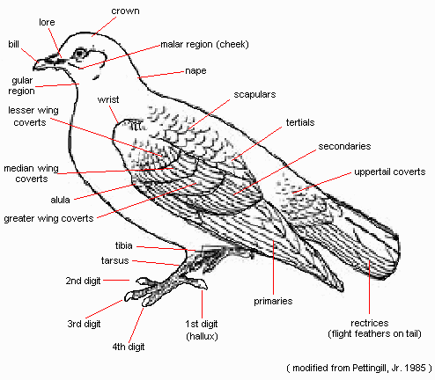

- Remove the pigeon’s eye. You are to try and remove the sclerotic ring – that is the bone inside the eye.
- Open up your pigeon’s mouth does it have teeth?
- Describe the pigeon’s tongue.
- Examine the hind legs and wings of the pigeon. The hind legs aren’t entirely covered by feathers.
- How many phalanges are on the hind legs?
- What are the hind limbs adapted to do?
- What are the wings adapted to do?
- What are the two types of feathers birds have?
- Remove one of each type of feather. Look at them under the dissecting microscope. Notice how you can preen the feathers yourself.
ICISIONS FOR SKINNING (Refer to page 4 in the dissection booklet)
9. Place your pigeon ventral side up in the tray. Part the feathers down the middle of the breast to expose bare skin. By running your finger from anterior to posterior between the now parted feathers you should be able to feel a bony ridge. This is the keel that anchors the large flight muscles.
10. Carefully with your scalpel make a VERY shallow incision along the keel. You only want to cut through the skin, not the muscle. The incision should extend from the neck to the vent. By using a blunt end probe and forceps you can cut the connective tissue holding the skin to the body. Peel the skin open to show the muscle.
11. What is the large muscle that is visible inside the chest cavity?

12. Cut open the muscle on top of the keel and open it up.
13. Next you are cutting away the keel. Cut away all the attaching ribs so that you can get to the internal organs.
14. You can now see the liver and the heart.
a. How many lobes are there to the liver?
b. Which is the largest?
c. How many chambers are there in the heart?
15. Cut up into the neck and find the crop and esophagus.
16. Cut open the crop. What is inside the crop?
a. What is the purpose of the crop?
b. What is the name of the fatty semi-liquid substance that the crop makes to feed to the young?
17. Next open up the stomach, what is inside the stomach?

18. Next remove the small intestines – you are to measure them. They are really long! Write their length below.

19. Locate the kidneys they are relatively large in the body cavity. There are two of them. They are connected by the ureter to the cloaca and vent.

20. Determine the sex of your pigeon – use the diagrams on page 13 and 14 to help you.
a. What is the sex of your pigeon?
b. How do you know?
21. Now you are going to examine the brain. Place your pigeon on its ventral side. Cut down the middle of the head from the cere to the base of the skull. Skin the head to expose the skull.
22. Cut a window in the skull and gently pull the square away. Now you have exposed the brain. Write down the parts to the brain that are visible from the dorsal view.

Bird Taxonomy
Domain: Subphylum:
Kingdom: Class:
Phylum:

