Name: _______________________________
Period:____________ Frogs vs Toads
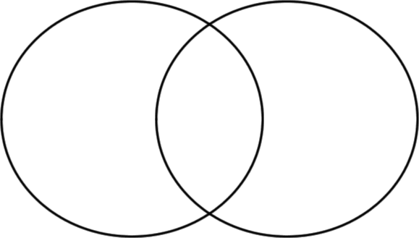

Words/phrases to Use in Venn Diagram
Frogs vs Toads
Are amphibians Eat insects
Have a backbone Nocturnal
Adults have lungs Hibernate
Young have gills
Long legs for jumping
Short legs for walking
Have a brain
Dry, warty skin
Slimy, smooth skin
Lays eggs in clusters
Lays eggs in chains
Bulging eyes
Hatch from eggs
Have a heart
Poison glands behind eyes
Have no teeth
Have teeth in top jaws
Young live in water
Females are larger than males

